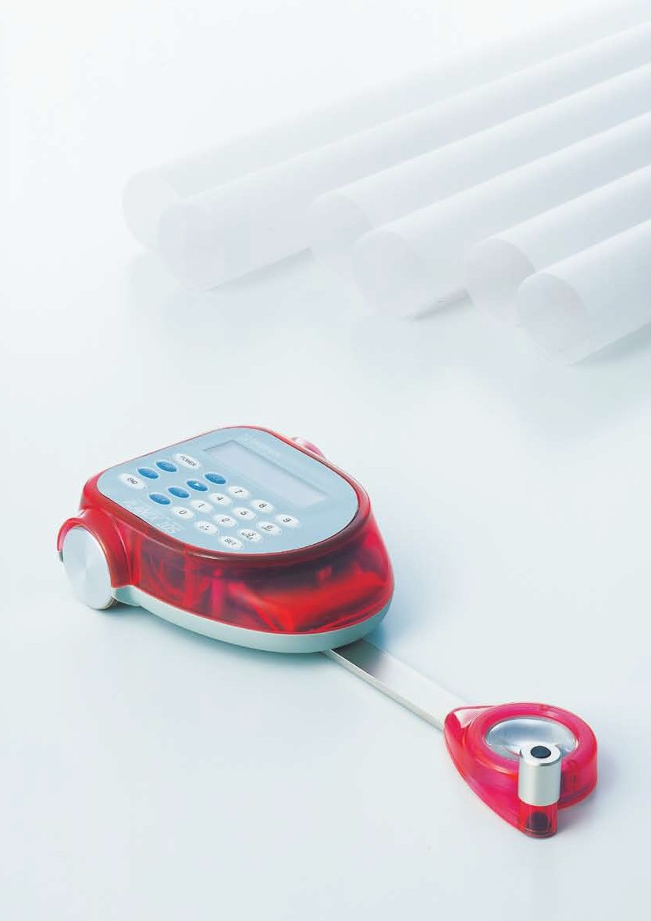PLANIX 10S

S t y l i s h !
Your best choice for
measuring area and line.

Compact, handy, and great look.
has made a comeback with new plotting feature.

●Metallic Grey

All plotting can be done with one hand.
●Pastel Blue

●Pastel Red

Switching by lines
Point/Stream(continuous) mode key allows conversion between point mode measurement for plotting points on straight lines and stream mode for tracing curves on curved lines.

Key Operation
At P1
Press PLOT Key. Move the tracing point to P2.
You do not need to trace a precise line from P1 to P2.

At P2
Press PLOT key. Move the tracing point to P3.
You do not need to trace a precise line from P2 to P3.

At P3
Press POINT/STREAM key to change to stream mode.Tracing along to curved line to P1. It shows measurement result automatically.

More Compact and Light Weight
The weight is only 630g and the compact design makes easier measurement.

More colorful measurement
3 colors, Metallic Grey, Pastel Blue, Pastel Red

Total and Average as you go
By measuring the same diagram a more number of times, a more accurate average or cumulative measurement for large scale diagrams can easily be carried out with these special keys.

Measurement of Reduced/Enlarged scale and the vertical scale with different horizontal scale
"marble" can also measure area of a scaled plan. The resulting measurement will be the dimentions of the object measured.

Auto-close function
Automatically finishes measuring when it is returned to the starting point during measurement.
- Specifications
Measuring Function : Area, Line, Side Length(s)
Measuring Scale : mm, cm, m, km, in, ft, acre/yd
Measuring Range : 300mm×10m
Measuring Accuracy :
±0.1%（100×100mm area measurement）
Display : LCD 16 digits on 2 lines
Minimum Line Reading : 0.05mm
Power : Internal nickel metal hydride battery or AC Charger/Adaptor
Battery Life : 20 hours use
Charging Time : 15 hours
Accessories : Storage Case, AC Charger/Adaptor Dimensions : 250（L）×110（W）×40（H）mm Weight : 630g.(without case)

* Specifications subject to change without notice.

PLANIX 10S

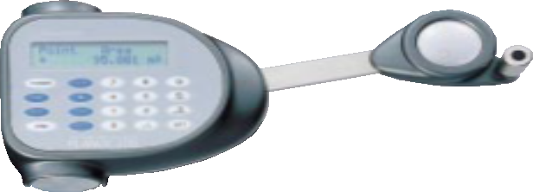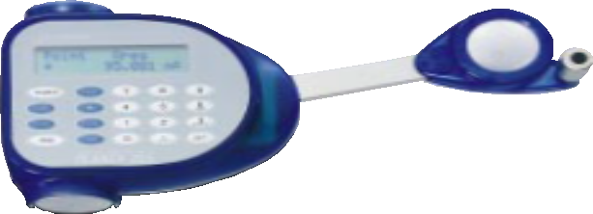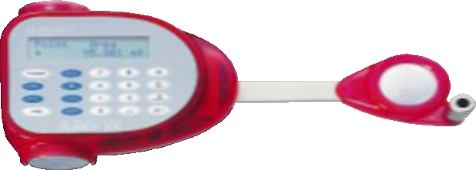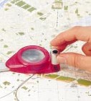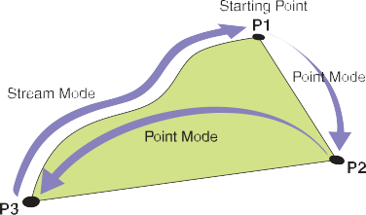
"marble"

G O !
TAMAYA TECHNICS INC., TOKYO, JAPAN www.tamaya-technics.com

